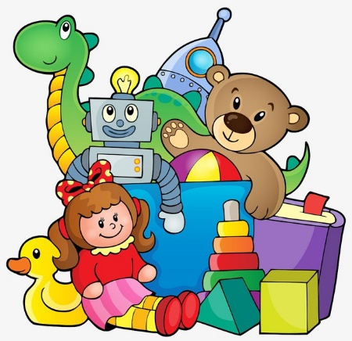
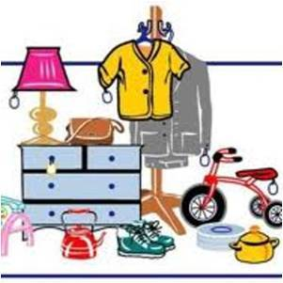

SEEKING items for DONATION to OUR SCHOOL
sale of work

Looking to do a spring clean, we would love if you would donate any of the below items?
- Good Quality clean clothing
- Handbags
- Household items (small)
- Games
- Childrens Toys
- Unwanted gifts/sets

All items must be clean and in good working order.

- Drop off can be done to Scoil San Eoin at 2pm or 3pm daily Monday – Friday
- Note: Collections may be possible, please contact the school office on schoolofficeredcross@gmail.com or 0404-41727 to arrange.
- All items must be received by Weds 27th March.

Thank You from all at Scoil San Eoin!
